**Data Flow Diagram:**

# Project Design Phase-II

**Data Flow Diagram & User Stories**

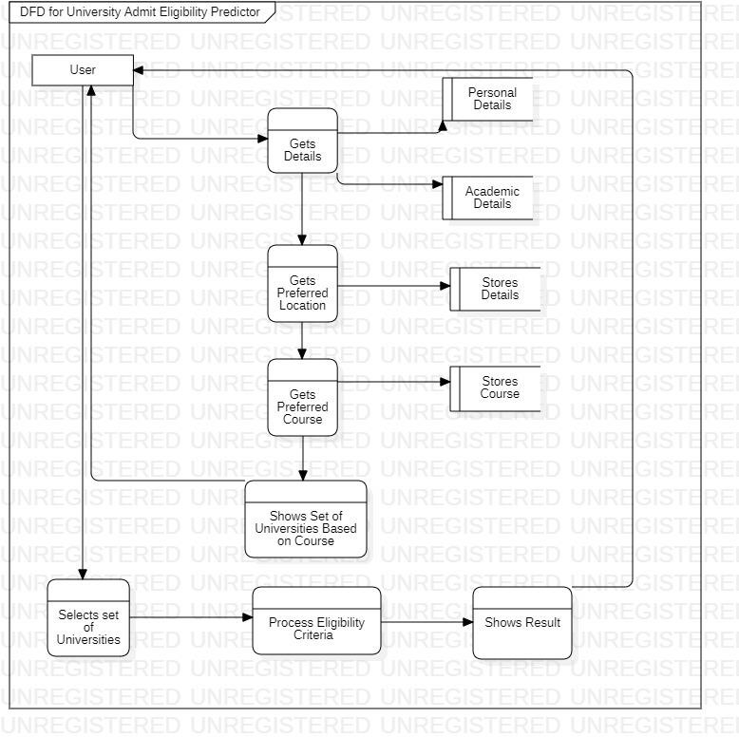

# User Stories

Use the below template to list all the user stories for the product.

|  |  |  |  |  |  |  |
| --- | --- | --- | --- | --- | --- | --- |
| **User Type** | **Functional Requirement (Epic)** | **User Story Number** | **User Story / Task** | **Acceptance criteria** | **Priority** | **Release** |
| Customer (Web user) | Personal Details | USN-1 | As a user, I can Give my academic information in the profile section | I can access my dashboard | High | Sprint-1 |
|  |  | USN-2 | As a user, I will be able to select a location that I prefer | I can receive the list of location in the dropdown  to select | High | Sprint-1 |
|  | Search | USN-3 | As a user I can search for my preferred university | I can use the search bar | Medium | Sprint-2 |
|  | User Preference | USN-4 | As a user, I can select my preferred university from the list to check my eligibility for the  particular university | I can use the dropdown list provided to select the  university | Medium | Sprint-2 |
|  |  | USN-5 | As a user, I can select my preferred location | I can select my preferred location | High | Sprint-1 |
|  |  | USN-6 | As a user, I will be able to select my preferred Course | I can select a course from the dropdown list | Medium | Sprint-1 |
|  | Result | USN-7 | As a user, I can view the list of universities that I am eligible in accordance to my preferred location | I can view the list of universities filtered by the model | High | Sprint-3 |
|  |  | USN-8 | As a user, I can access the link to the university that I am eligible from the list | I can access the university link | Medium | Sprint-3 |
|  |  | USN-9 | As a user, I can access the location link of the university that I am eligible from the list | I can access the university location link | Low | Sprint-3 |
|  |  | USN-10 | From the list of universities, I can select and view the eligibility for the particular  university | I can view the eligible university | Medium | Sprint-3 |